Skill 06 Lab 2 - Tracking Switch Interface & CAM Table (May 27)
Step-by-Step Guide to Create the Network Design in Cisco Packet Tracer
This guide helps a new learner build the topology shown in the lab diagram and prepare it for interface and CAM table practice.
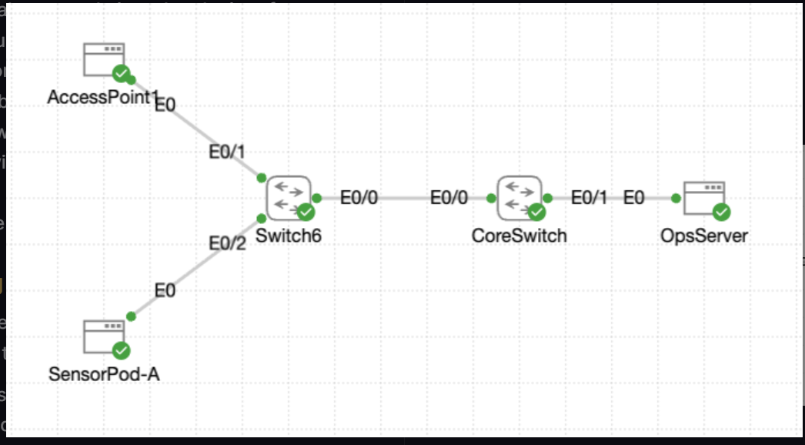
Figure 1. Reference topology for Skill 06 Lab 2.

1. Lab Goal
Build a small switched network in Packet Tracer with two switches, one access point, one sensor pod, one operations server, and one core switch path. The finished topology will let you practice interface identification, port mapping, and CAM table learning.

2. Devices to Place
Device | Packet Tracer Choice | Label in Diagram
Switch | 2960 switch | Switch6
Switch | 2960 switch | CoreSwitch
Access Point | Access Point-PT | AccessPoint1
End Device / IoT or Generic host | End device to represent SensorPod-A | SensorPod-A
Server | Server-PT | OpsServer
Note: Device names in Packet Tracer may differ slightly from the diagram. That is okay as long as you rename them to match the lab picture.

3. Recommended Layout
Place AccessPoint1 at the upper left.
Place Switch6 below the access point.
Place SensorPod-A below and left of Switch6.
Place CoreSwitch to the right of Switch6.
Place OpsServer to the right of CoreSwitch.
Leave enough space between devices so interface labels remain readable.

4. Rename the Devices
After placing the devices, click each device, open the Config tab, and change the Display Name so the workspace matches the diagram:
AccessPoint1
Switch6
SensorPod-A
CoreSwitch
OpsServer

5. Cable the Topology
Use Copper Straight-Through cables for all connections in this lab. Packet Tracer may auto-select ports if you choose the automatic connection tool, but it is better to pick the interfaces manually so you can track them during verification.
From Device | From Port | To Device | To Port
AccessPoint1 | E0 | Switch6 | E0/1
SensorPod-A | E0 | Switch6 | E0/2
Switch6 | E0/0 | CoreSwitch | E0/0
CoreSwitch | E0/1 | OpsServer | E0

6. Step-by-Step Build Process
1. Open Cisco Packet Tracer and create a new file.
2. From Network Devices, drag one 2960 switch to the workspace and rename it Switch6.
3. Drag a second 2960 switch to the workspace and rename it CoreSwitch.
4. From Wireless Devices, drag one Access Point-PT to the workspace and rename it AccessPoint1.
5. From End Devices, drag one Server-PT to the workspace and rename it OpsServer.
6. Add one end device to represent SensorPod-A. Rename it SensorPod-A.
7. Arrange the devices so the layout matches Figure 1.
8. Click Connections and choose Copper Straight-Through.
9. Connect AccessPoint1 E0 to Switch6 E0/1.
10. Connect SensorPod-A E0 to Switch6 E0/2.
11. Connect Switch6 E0/0 to CoreSwitch E0/0.
12. Connect CoreSwitch E0/1 to OpsServer E0.
13. Wait for the link lights to turn green.

7. How to Verify the Physical Design
After cabling, confirm the design matches the diagram before you move on to CLI work.
AccessPoint1 should connect only to Switch6.
SensorPod-A should connect only to Switch6.
Switch6 should have one uplink to CoreSwitch.
CoreSwitch should connect to OpsServer.
Each link should show the same interface names as the diagram.
All link status indicators should be green.

8. Why This Design Matters for the Lab
This topology creates a simple path for traffic to move from end devices on Switch6 toward CoreSwitch and then to OpsServer. Once traffic flows, each switch can learn source MAC addresses in its CAM table. That makes the design ideal for practicing:
which interface a frame enters on,
how a switch learns MAC addresses,
how to read show mac address-table output, and
how to trace a device location by its switch port.

9. Suggested Verification Commands
After the topology is built and basic IP settings are added later in the lab, these CLI commands are commonly used to study interfaces and the CAM table.
Where to Run | Command
On Switch6 or CoreSwitch | show interfaces status
On Switch6 or CoreSwitch | show mac address-table
On Switch6 or CoreSwitch | show mac address-table dynamic
On Switch6 or CoreSwitch | show cdp neighbors
On OpsServer or SensorPod-A | ping <destination IP>

10. Common Mistakes to Avoid
Using the wrong port numbers and ending up with a topology that does not match the diagram.
Placing the correct devices but forgetting to rename them.
Connecting devices with the wrong cable type.
Moving on to CLI verification before link lights are green.
Ignoring the interface labels shown next to each cable.

11. Completion Checklist
☐ The workspace layout looks like the diagram.
☐ AccessPoint1 is connected to Switch6 E0/1.
☐ SensorPod-A is connected to Switch6 E0/2.
☐ Switch6 E0/0 is connected to CoreSwitch E0/0.
☐ CoreSwitch E0/1 is connected to OpsServer E0.
☐ All devices are renamed correctly.
☐ All links are up and green.

8. Perform the Training Tasks
Use this section after the topology is built. These steps teach you how to read switch interfaces, verify link health, and use the CAM table to locate devices in the network.

Training Objectives
- Distinguish interface naming conventions and roles using the switch summary views.
- Evaluate duplex and speed negotiation on active ports to flag connectivity issues early.
- Correlate interface descriptions and CAM table entries to pinpoint where devices live.

Task 0 - Read the Interface Roll Call
From the Switch6 console, confirm you can reach the elevated prompt, then pull the quick status sheet that lists every interface so you can see which Ethernet ports are live versus dormant.

Steps
- Open Switch6, go to the CLI tab, and press Enter until you see the user EXEC prompt.
- Move from the user prompt to the privileged prompt:
enable
- Display the concise interface roster that shows each port name, IP assignment, and operational state:
show ip interface brief
- Review the output and note the interface numbering Ethernet0/0 through Ethernet0/3 so you can match ports to the deployment diagram.
- Confirm which ports are up, which are administratively down, and which are unused in this lab.

Task 1 - Inspect Duplex and Speed Negotiation
Still at the privileged prompt, call up the status view that reveals duplex, speed, and VLAN information so you can verify everything is running full tilt and auto-negotiated correctly.

Steps
- Stay at the Switch6# prompt and display the interface status snapshot:
show interfaces status
- Focus on Et0/0 for the core uplink, Et0/1 for AccessPoint1, and Et0/2 for SensorPod-A.
- Check the Duplex and Speed columns. Healthy links should show full duplex and an auto-negotiated speed that matches the device on the other side.
- Record any port that drops to half duplex or unexpectedly locks to a low speed so you can escalate it for follow-up.
- Compare the active ports to the topology to confirm the correct interfaces are carrying live traffic.

Task 2 - Match Descriptions to Physical Runs
Use the switch interface descriptions to tie interfaces back to their cable endpoints so you can avoid tracing wires in the dark.

Steps
- From the Switch6# prompt, display the interface description view:
show interfaces description
- Read the descriptions and map the interfaces to the topology: Et0/0 = core uplink, Et0/1 = AccessPoint1, and Et0/2 = SensorPod-A.
- Confirm that each described interface is in the state you expect based on the topology and cabling.
- If a port description does not match the device connected to it, note the mismatch before continuing.

Task 3 - Trace Devices with the CAM Table
Interrogate the MAC address table to locate the coffee shop endpoints and recognize when a port is actually another switch in disguise.

Steps
- From Switch6#, display the learned MAC address table:
show mac address-table
- Review which interfaces are populated. The uplink port usually lists multiple remote MAC addresses because another switch and downstream devices are behind it.
- Identify the uplink by finding the interface that shows multiple learned MAC addresses, including the CoreSwitch and the OpsServer behind it.
- Filter the table for the access point MAC address 5a5a.1c1c.0d0d so you can immediately confirm the expected port:
show mac address-table address 5a5a.1c1c.0d0d
- Verify that the filtered result points to the interface connected to AccessPoint1.
- Use the CAM table together with the interface descriptions to explain where each endpoint lives in the topology.

Completion Check
- The interface summary on Switch6 confirms the state of Ethernet0/0 through Ethernet0/3.
- The status report shows full-duplex, healthy links for AccessPoint1, SensorPod-A, and the core uplink, or flags any negotiation issues you noted.
- The MAC address table review pinpoints where each device connects and highlights which ports backhaul to the core.
- Castle Rysen now knows you can read a switch like a storybook - consider yourself cleared to audit the rest of the bunker floor.

Quick Verification Commands
enable
show ip interface brief
show interfaces status
show interfaces description
show mac address-table
show mac address-table address 5a5a.1c1c.0d0d

